Downloading and Installing R and Rstudio.

## Background

R is the program/application (and also refers to the programming language, i.e. the syntax) that is doing the heavy lifting behind the scenes.

Rstudio is a free user interface developed by the people at Posit. It provides a lot of nice features and buttons that can really help writing, testing, and running R code. We tend to use Rstudio instead of coding directly in R. Note: there are options besides Rstudio, such as Visual Studio, which have been growing in popularity recently.

## Installation Steps

First, open the Software Center. Scroll down to the programs beginning with ‘R’ and install:

1. RforWindowsX64 4.2.2 Gen P0
2. RStudioX64 2022.07.2.576

Second, open up Rstudio and find the drop-down menu item at the top of your screen labelled “Tools”. Go to “Global Options” (see figures below). Under R sessions, there’s an option called ‘R version’: we’ll need to point RStudio to the more recent version of R (4.2.2 or more recent) that we installed from the software center.

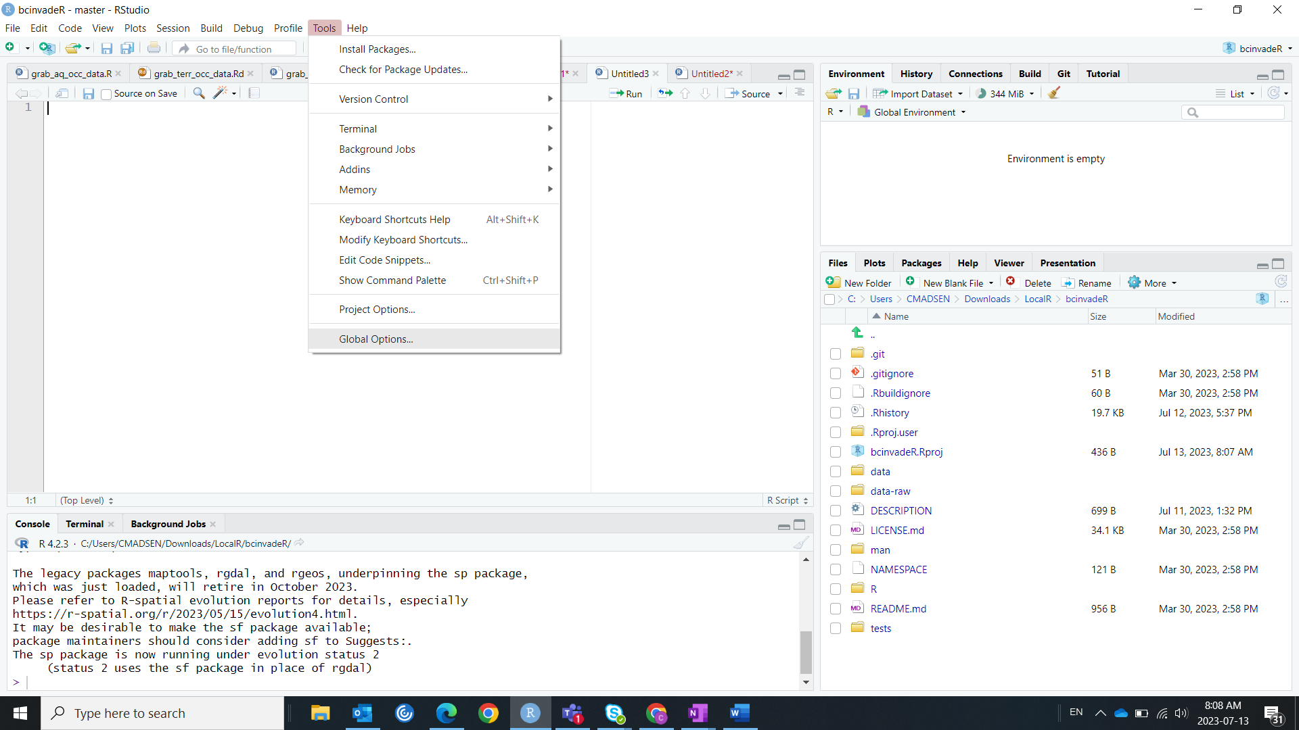

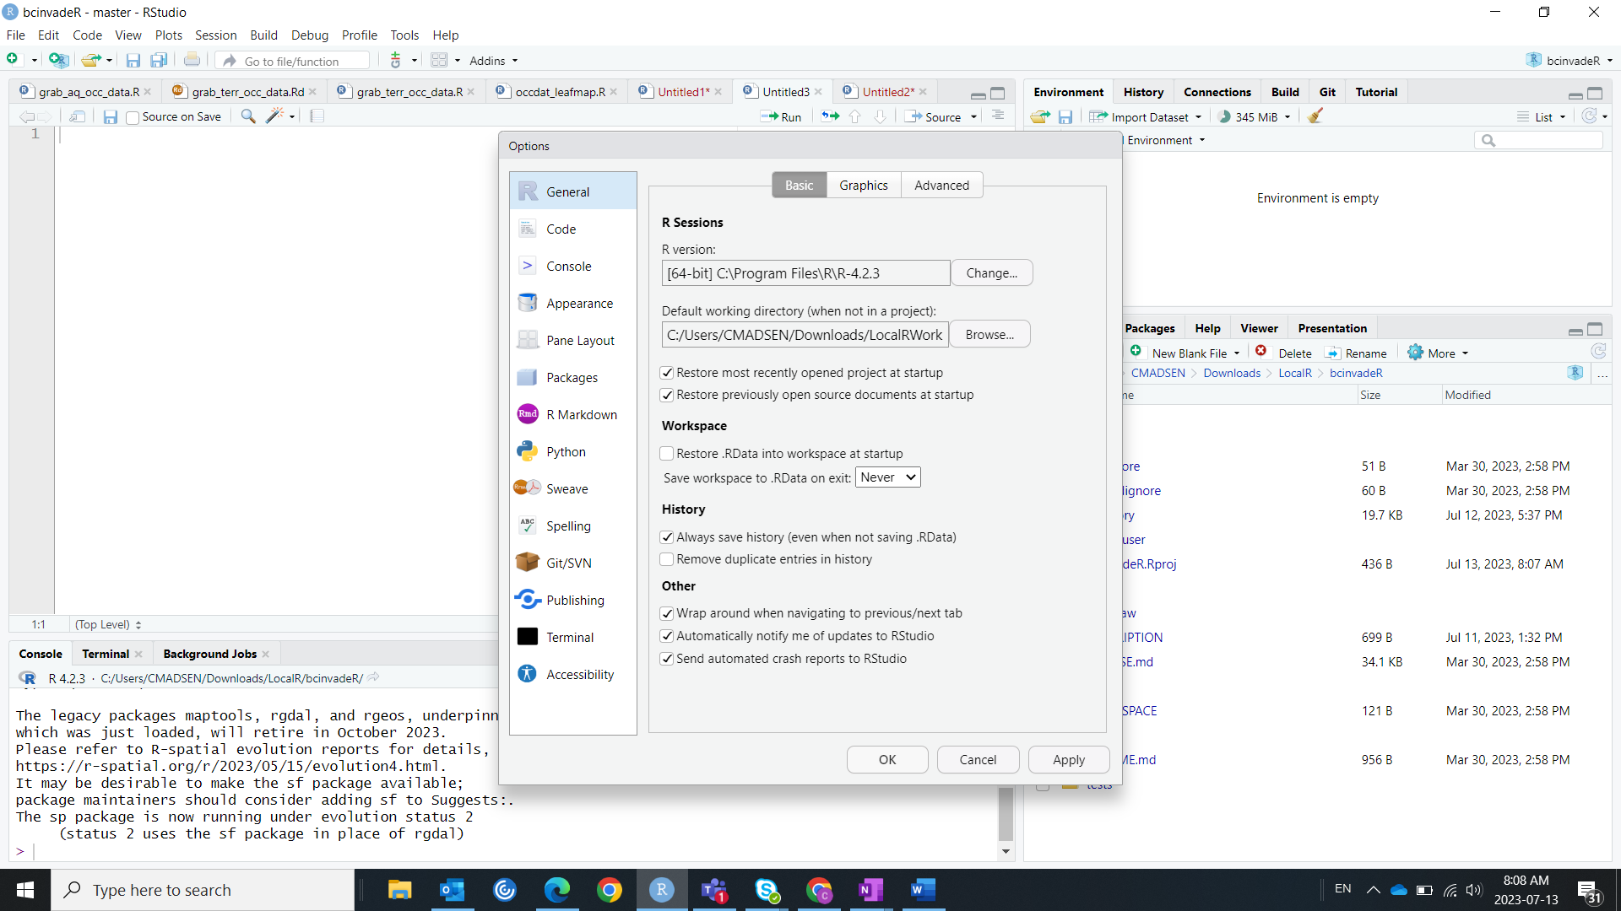

## Folder Set-up and a few words of caution

The usual installation folder chosen by the Software Center is on your H: drive (your personal drive on the LAN network). There are 2 issues with this:

1. We are not supposed to store large files on that drive.
2. It’s very slow to read and write files to that drive, compared to having a folder on your local laptop.

For those reasons, I recommend that you make a folder on your computer to store your R project(s). I have a folder in Downloads that is called ‘LocalR’ (i.e. the folder path is C:/Users/CMADSEN/Downloads/LocalR), inside of which all of my projects live (you do not need administrative privileges to download files to the Downloads folder!). Some people create a folder directly under the C: drive (i.e. the folder path is C:/temp), usually called ‘temp’ or something similar, which can also work.

Some lessons I’ve learned the hard way:

1. Try to split your projects into R projects; this makes it easy to keep all relevant R scripts, data, and results in a single place.

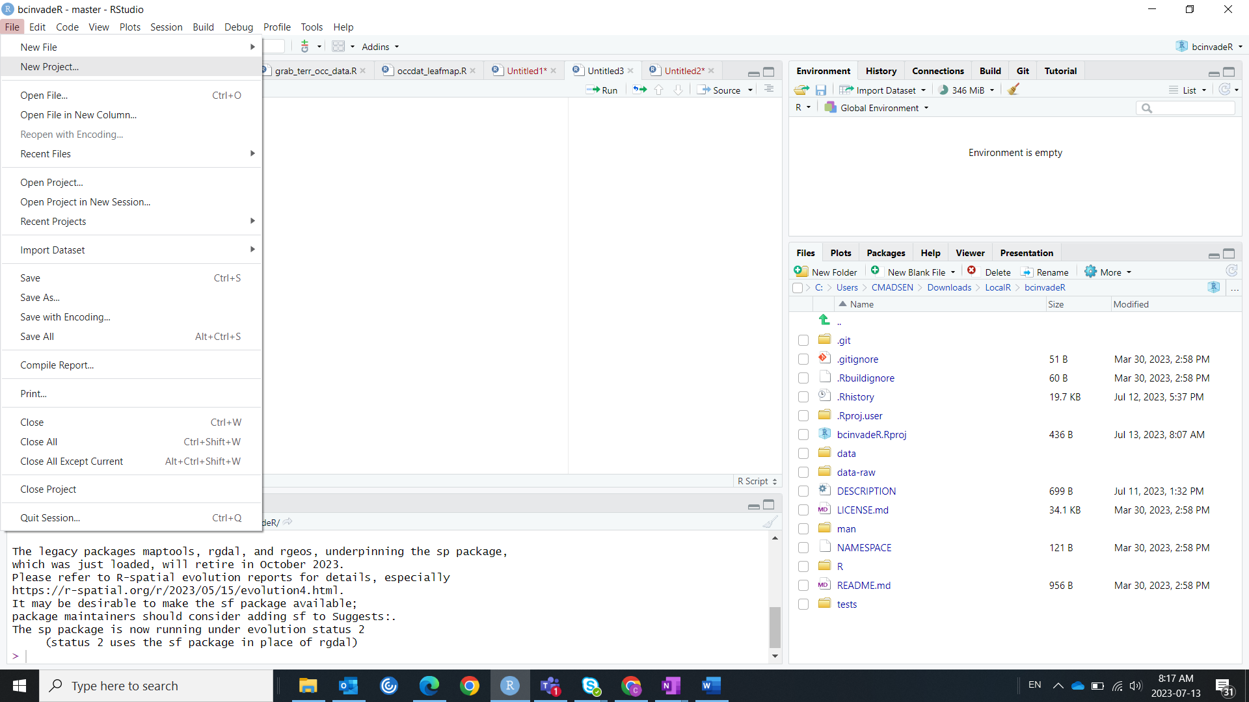

1. Don’t save your working environment to your computer (you’ll be asked if you’d like to do this whenever you close RStudio) – if you do this, the Rdata object will grow and grow, and eventually, you may find yourself *unable to recreate your data objects or results*. Instead, I recommend that you write your R scripts so that you can run them from start to finish and it will produce identical results every time. This may be a little vague, I hope the figure below can illustrate one form of ‘bad’ organization of a script. If it’s still unclear, we can chat about this!

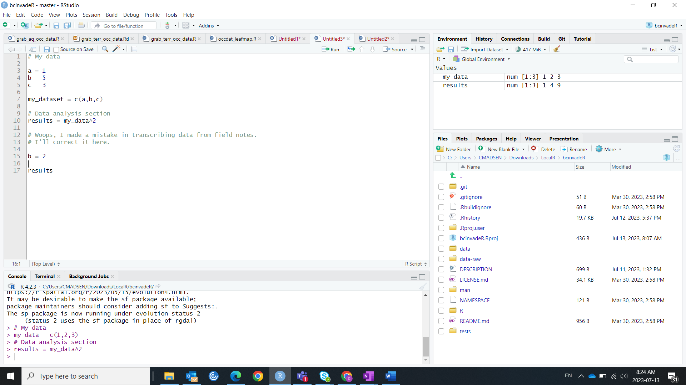

Would be better to correct in line 4. Now ‘results’ won’t match our data.

Now you should be ready to rock and roll!